Table STD-10 Selection of Wires and Circuit Protection Devices

|  |  |  |  |  |  |  |  |  |  |  |  |  |  |  |  |  |
| --- | --- | --- | --- | --- | --- | --- | --- | --- | --- | --- | --- | --- | --- | --- | --- | --- |
| No. | Power Line  Wire | Max. Applied  Load(A) | Max. Blow  Current of Protection  Device (A) | Crew accessible Wire/Cables (Yes/No) | Downstream Wire | | | | | | | | | Compatibility for Wire Derating  (Yes/No) | Compatibility for Touch Temperature  (Yes/No) | Remarks |
| Size (AWG) | Rated.  Temp  (℃) | Current Carrying Capacity of a Single Wire (A) | Current limit to meet touch temperature limited (A) ※2 | Quantity;  Hot/Return | Bundled (Yes/No) | Bundle  Factor | Derating Current (A) | Smart Short Current (A) |
| 1 | DepSW2 signal line | 267.4x10-6 | N/A | No | AWG30 | 200 | 1.3※1 | - | 1 | No | N/A | 1.3 | N/A | Yes | - |  |
| 2 | Battery cable | 379.9x10-6 | N/A | No | AWG22 | 150 | 5.92※3 | - | 4 / 4 | No | N/A | 7.4 | N/A | Yes | - |  |
|  |  |  |  |  |  |  |  |  |  |  |  |  |  |  |  |  |

Note:　Ambient Temperature +22.2℃, Ambient Pressure: 10-6 torr)

※1: Based on JAXA-JERG-2-212 5.2.1 Table 5.2-1 RECOMMENDED MAXIMUM CURRENT FOR SINGLE LINE as there was no indicattion of wire size to be used for SSP51721 4.3.1.2 Table 4.3.1.2-1.

※2: N/A because the target wire cannot be touched by the crew

※3: Based on SSP51721 4.3.1.2 Table 4.3.1.2-1 WIRE SIZE DERATING AND CIRCUIT PROTECTION Column A

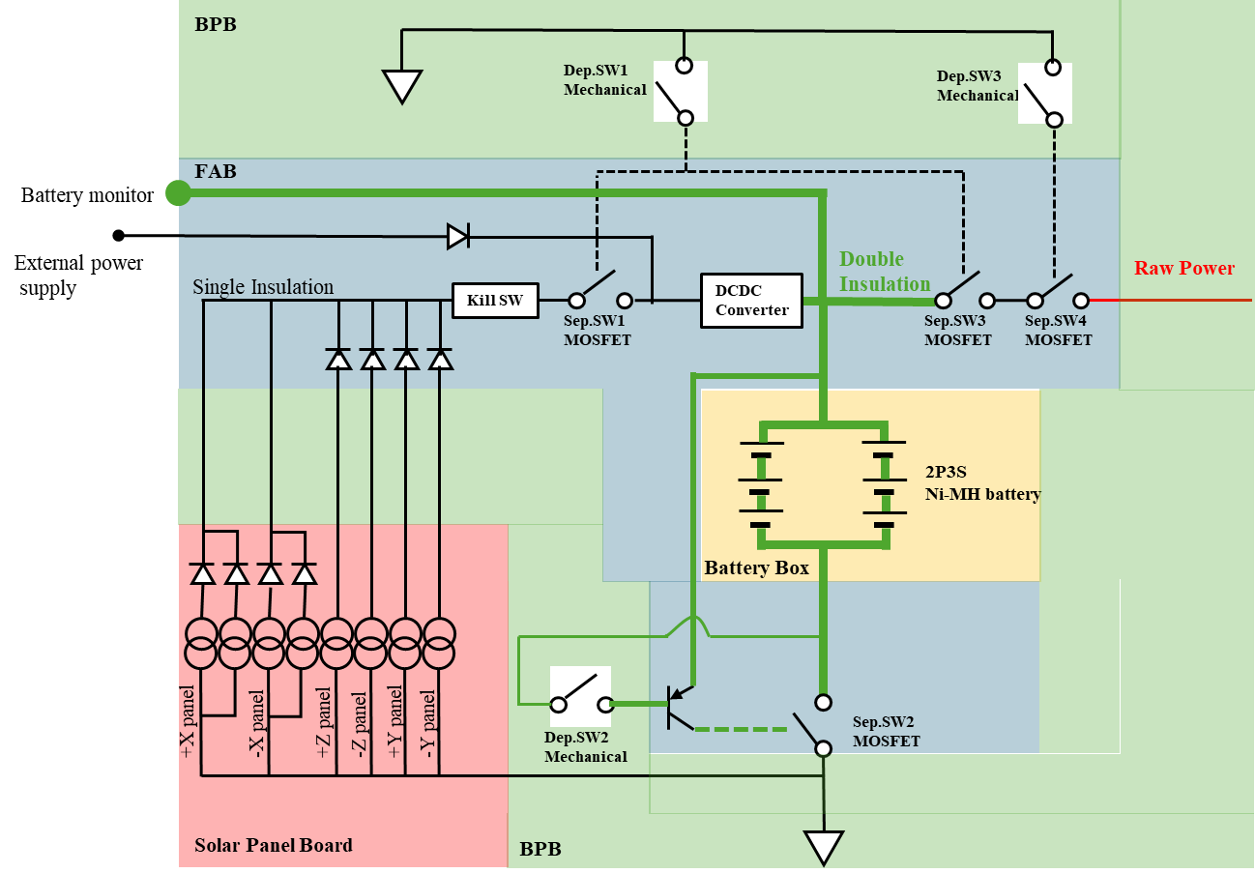

1. Wire



1. Wire

